- Get User details using userId
http://www.dwappdemo.co.za:8088/cisorigin.uam.rest/api/v1/user/' + UID
- POST- Triger Task http://www.dwappdemo.co.za:9092/triggertask
{
"processid": 1,
"provinceid": 2,
"loggeduserid": 1045,
"notes": "Spital data request from GIS ",
"context": "DataRequest",
"type": 1,
"processdata": "{wkt:1212121,12121212}",
"parentworkflowid": 0,
"assignedtouserid": 1045
}

assignedtouserid
UserID | ProvinceID | ProvinceCode
1046 | 3 | GT
1042 | 7 | EC
1047 | 5 | FS
1048 | 1 | LP
1049 | 2 | MP
1050 | 8 | NC
1043 | 4 | NW
1044 | 9 | WC
1052 | 6 | NL

- POST- Add data to Cart Table http://dwappdemo.co.za:8088/cisorigin.uam.rest/api/v1/cart/addCartHook

Input:
{
"addressData": "{\"selectedMode\":{\"itemId\":206,\"itemCode\":\"DLM006\",\"listCode\":16,\"caption\":\"ELECTRONIC\",\"description\":\"ELECTRONIC\",\"isActive\":1},\"deliveryMedia\":{\"itemId\":166,\"itemCode\":\"MEDIA005\",\"listCode\":18,\"caption\":\"FTP\",\"description\":\"FTP\",\"isActive\":1},\"name\":\"NAT_Admin Admin\",\"email\":\"1111nat_admin@drdlr.gov.za\",\"phone\":\"5555123456\",\"ownMedia\":false,\"collectionAddress\":\"\"}",
"cartData": [
{
"dataKey": "string",
"dated": "2021-03-09T12:59:52.755Z",
"jsonData": "{\"searchDetails\": {\"preview\": \"http://dwapps.co.za/DRDLRRM/CSGTIF/10EIL6010.jpg,\", \"province\": \"EASTERN CAPE\", \"documentType\": \"Spaital\", \"provinceCode\": \"7\", \"documentSubtype\": \"Spaital\" }, \"cartData\": {\"spatial\": true, \"spatialData\": [{\"type\": {\"itemId\": 2055, \"itemCode\": \"2055\", \"listCode\": 24, \"caption\": \"SHAPE\", \"description\": \"SHAPE\", \"isActive\": 1 } } ] } }",
"provinceId": 2,
"searchTypeId": 0,
"userId": 1042,
"workflowId": 11067
}
],
"dated": "2021-03-09T12:59:52.755Z",
"provinceId": 2,
"requestorData": "{}",
"userId": 1042,
"workflowId": 11067
}

4- Notification- Logged Bulk Request
http://dwappdemo.co.za:8088/cisorigin.uam.rest/api/v1/email/send

{
"contentEntry": {
"&lt;&lt;Name&gt;&gt;": "tttttt",
"&lt;&lt;REFERENCE_NUMBER&gt;&gt;" :"REF1ddddddd234"

},
"sendToEmailId": "gairola.arvind@gmail.com",
"templateId": 13
}

5- Email Notification for Spatial Data Share:
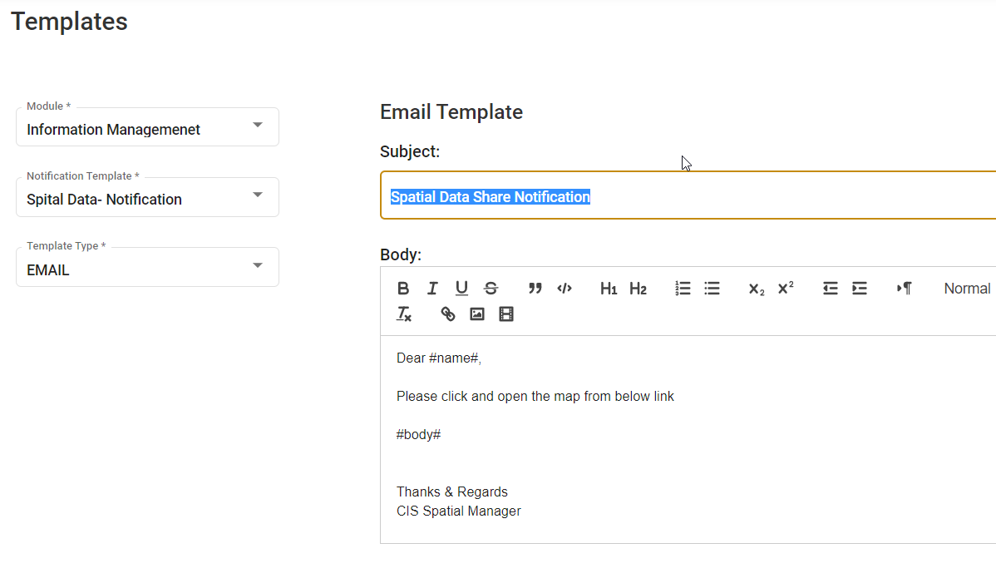
http://dwappdemo.co.za:8088/cisorigin.uam.rest/api/v1/email/send

{
"contentEntry": {
"#body#": "tttttt",
"#name#" :"REF1234"

},
"sendToEmailId": "gairola.arvind@gmail.com",
"templateId": 187
}

6- Log all the Search Data- http://dwappdemo.co.za:8088/cisorigin.uam.rest/api/v1/search/log
{
"caption": "Test",
"data": "test",
"provinceId": 2,
"searchFilterId": 21,
"searchTypeId": 2121,
"userId":1045
}

Stat Map
7- http://dwappdemo.co.za:8088/cisorigin.uam.rest/api/v1/dashboard/mapview

